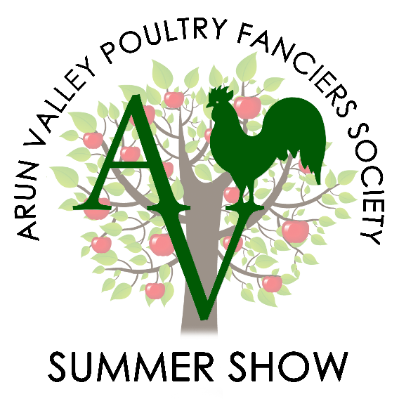

Arun Valley Poultry

Fanciers Society

Poultry Show:

SATURDAY 10TH JUNE 2017

Poultry Sale:

THURSDAY 8TH – SATURDAY 10TH JUNE 2017

*By kind permission of the South of England Agricultural Society*

At the South of England Show

South of England Show Ground, Ardingly, West Sussex, RH17 6TL

**Judges:**

Jim Young & Neil Scutt

**Poultry Club Representative:**

Jed Dwight

**All Entries & fees to be sent to the secretary** (details below)

Entry fee £1.50 per show entry, 50p per plate of eggs & £1.50 per sale entry.

Exhibitors entering more than 5 birds or 10 plates of eggs will be entitled to one free pass. Children under 16 are free.

Show & Sales Rules are on the rear pages

CLOSING DATE FOR SHOW AND SALE ENTRIES FRIDAY 2RD JUNE 2017.

Any late entries may not receive passes.

Entry for the sale will be closed early if pens are filled due to limited space at the venue.

**Please make cheques payable to AVPFS**

**Jan Pannell, 116 Findon Road, Worthing, West Sussex, BN14 0AT.**

South of England Show Awards

Best Large Fowl Hard Feather

Best Large Fowl Soft Feather

Best Bantam Hard Feather

Best Bantam Soft Feather

Best True Bantam

Best Rare Breed

Best Non-Standard

Best Waterfowl

Reserve Best In show

**Overall Best in Show**

Best Pet

Best Juvenile

Best Trio

Best Eggs

# Bird flu & the show

# Section Classification

Classes will be split if sufficient entries are received

1. Egg Classes
   1. 3 Maran Large Fowl Eggs
   2. 3 Welsummer L/F Eggs
   3. 3 Araucana Eggs L/F
   4. 3 Brown/Brown Mottled Large Fowl Eggs
   5. 3 White/Cream L/F Eggs
   6. 3 AOC Large Fowl Eggs
   7. 3 Distinct Colour L/F Eggs
   8. 1 Marans Large Fowl Egg
   9. 1 Welsummer L/F Egg
   10. 1 Araucana Egg L/F
   11. 1 Brown/Brown Mottled Large Fowl Egg
   12. 1 White/Cream L/F Egg
   13. 1 AOC Large Fowl Egg
   14. 3 Maran Bantam Eggs
   15. 3 Welsummer Bantam Eggs
   16. 3 Araucana Bantam Eggs
   17. 3 Brown/Brown Mottled Bantam Eggs
   18. 3 White/Cream Bantam Eggs
   19. 3 AOC Bantam Eggs
   20. 3 Distinct Colour Bantam Eggs
   21. 1 Maran Bantam Egg
   22. 1 Welsummer Bantam Egg
   23. 1 Araucana Bantam Egg
   24. 1 Brown/Brown Mottled Bantam Egg
   25. 1 White/Cream Bantam Egg
   26. 1 AOC Bantam Egg
   27. 3 Waterfowl Eggs
   28. 1 Waterfowl Egg
   29. 6 Large Fowl Eggs AC
   30. 6 Bantam Eggs AC
   31. 6 Waterfowl Eggs AC
   32. Large Fowl Contents
   33. Bantam Egg Contents
   34. Large Fowl Int/Ext
   35. Bantam Egg Int/Ext
   36. Best Decorated Egg

# 2016 Winners

La

La

La

Lal

A

La

La

La

Lal

# Save the Dates!

If you can’t make the show this year, or your birds aren’t performing don’t worry there are two more shows with even more classes for you to enter!

Autumn Show & Game Fair

Show: Sunday 1st October 2017

Sale: Saturday 30th September & Sunday 1st October 2017

We look forward to seeing you!

# Show Rules and Regulations

* Show to be held under Poultry Club of Great Britain rules (copies available on their website)
* Show will be held under and DEFRA Regulations in place at the time of event.
* Arun Valley Poultry Fanciers Society will not be held responsible for any damage/loss to any competitor or their property either at time of show or after.
* All exhibits must be penned/displayed by 9.00am. No exhibits are to be removed prior to 4:30pm on day of show. Once penned birds must not be removed by anyone other than appointed stewards and judges.
* Entry onto the SEAS showground after 8:30am will be on foot only.
* No Exhibitor may engage in conversation with the any Judges or Judges Stewards on the day of the show prior to the completion of all judging. Exhibitors caught ignoring this may be subject to disqualification.
* Where there is a class for male and female of the same breed, we (AVPFS) reserve the rights to amalgamate if insufficient numbers.
* Duplicated entries will not be accepted.
* Rosettes will only be awarded if 3 or more exhibits are entered.
* All birds must have been bona fide property of the exhibitor for at least 28 days prior to the show.
* All birds must comply with any DEFRA regulations in force at the time of the show and be transported in line with current welfare regulations. We reserve the right to remove or exclude any birds considered unhealthy.
* Juvenile exhibitors must be 16 years or younger on the day of the show.
* All persons making entries will be deemed to have read these rules and agreed to be bound by them.

# sale rules for eggs

* When selling hatching eggs, they must be no more than 5 days old and should be proven to be fertile (that you have hatched from the same stock this year).
* They must be from birds who have a cockerel running with them for sufficient time to fertilise eggs provided for sale.
* All boxes must be marked with the breeder’s name and telephone number. We expect providers of fertile eggs to replace eggs where the WHOLE box is shown to be infertile but not those which have failed during incubation.
* If you are selling eggs from unproven pens of birds, then this must be indicated on your box so the buyer is aware.
* There is a maximum of 15 boxes of eggs per person and all boxes must be labelled with your name, address, telephone number & breed of bird.

**Notes**:

* Pen numbers will be given on the day.
* Poultry Club Representative: Displayed on day of show.

Contact Information

Please note that on show days’ signal at the Showground is poor so you may need to try us a few times.

# Club Secretary:

Jan Pannell

116 Findon Road, Worthing,

West Sussex,

BN14 0AT

Email: [janpannell@btinternet.com](mailto:janpannell@btinternet.com)

Mobile: 07796438571

# Club Treasurer

Karen Barnett-Cottle

# Schedule / Sale Information:

David Pannell

116 Findon Road,

Worthing,

West Sussex,

BN14 0AT

Email: [smaviddavid@hotmail.co.uk](mailto:smaviddavid@hotmail.co.uk)

Mobile: 07429 258158